Capstone Project-3

B-Safe

Problem Description:

Create a CI/CD Pipeline to convert the legacy development process to a DevOps process.

Background of the problem statement:

A leading US healthcare company, Aetna, with a large IT structure had a 12-week release cycle and their business was impacted due to the legacy process. To gain  
true business value through faster feature releases, better service quality, and cost optimization, they wanted to adopt agility in their build and release process.  
The objective is to implement iterative deployments, continuous innovation, and automated testing through the assistance of the strategy.

Implementation requirements:

* Install and configure the Jenkins architecture on AWS instance
* Use the required plugins to run the build creation on a containerized platform
* Create and run the Docker image which will have the application artifacts
* Execute the automated tests on the created build
* Create your private repository and push the Docker image into the repository
* Expose the application on the respective ports so that the user can access the deployed application
* Remove container stack after completing the job

The following tools will be used:

* EC2
* Jenkins
* Docker
* Git

Assumptions:

* We assume there is already a master server with Jenkins and docker installation, before proceeding we do basic validations as below.

Fig 1/Fig2

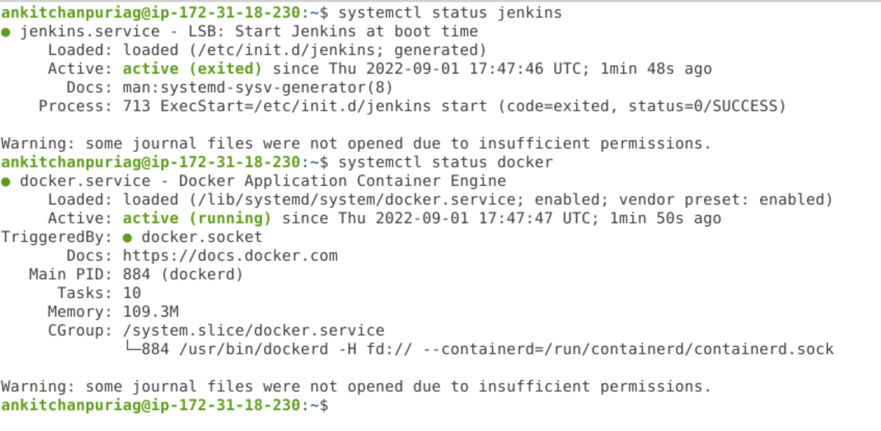

Solution Approach:

Jenkins Slave Configuration on Amazon Ec2 instance:

Since we plan to implement a CI/CD pipeline we will strengthen our Jenkins master server by converting standalone installation into Jenkins master and slave architecture, we will provision a EC2 instance using terraform for slave configuration.

1. Pull the code from repository.
2. Update the vars.tf with ACCESS KEY,SECRET KEY and SECURITY TOKEN from the console as below

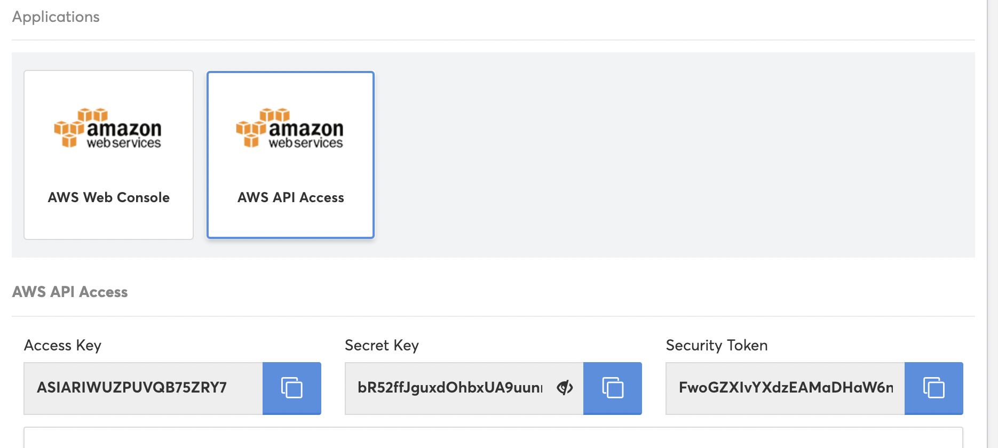

ubuntu@ip-172-31-18-230:/home/ankitchanpuriag/capstone_project/ec2_instance$ vi vars.tf

1. Generate a key pair and replace the capstone_project.pem downloaded from repository with it.

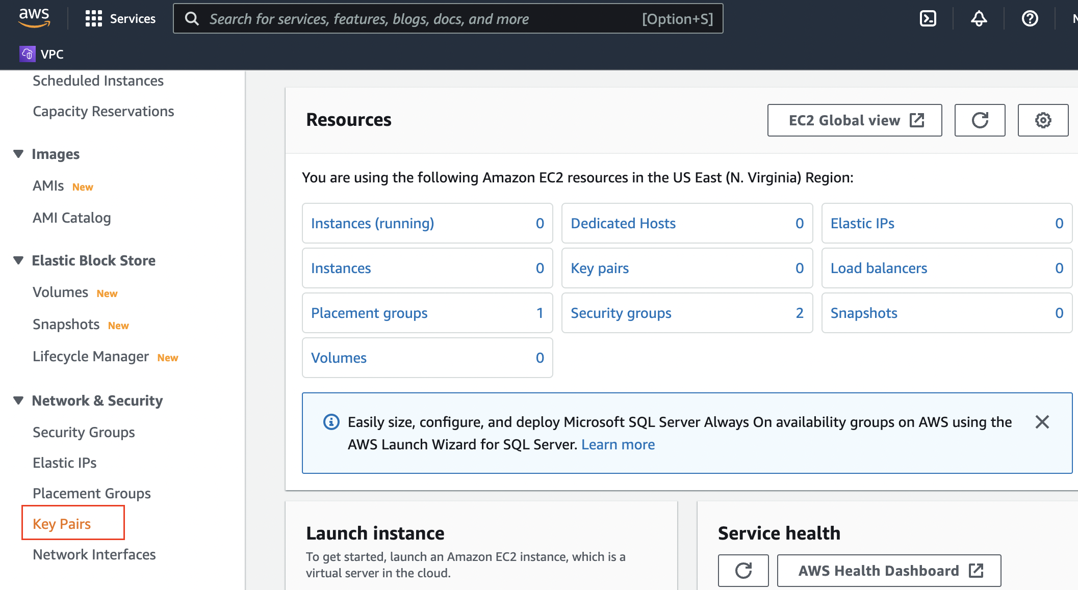

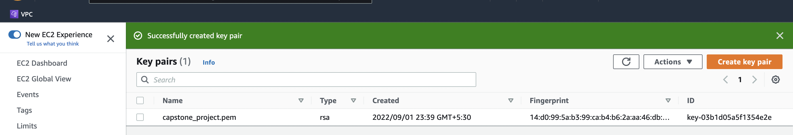

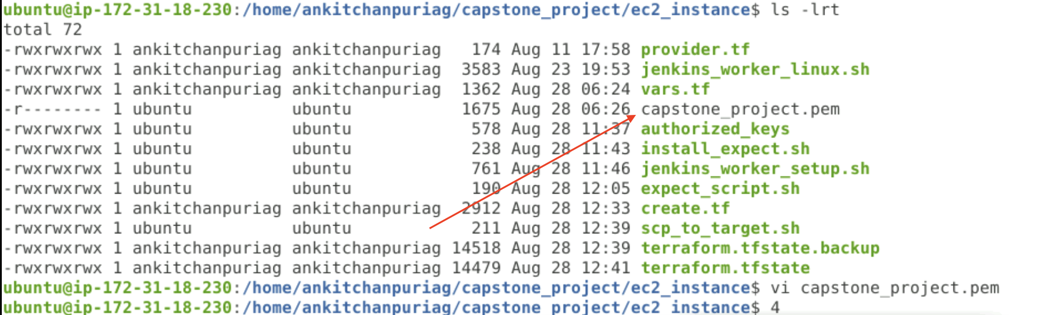

1. Then perform terraform INIT,VALIDATE PLAN and APPLY as below.

ubuntu@ip-172-31-18-230:/home/ankitchanpuriag/capstone_project/ec2_instance$ terraform init

Initializing the backend...

Initializing provider plugins...

- Reusing previous version of hashicorp/aws from the dependency lock file

- Reusing previous version of hashicorp/template from the dependency lock file

- Using previously-installed hashicorp/aws v4.25.0

- Using previously-installed hashicorp/template v2.2.0

Terraform has been successfully initialized!

You may now begin working with Terraform. Try running "terraform plan" to see

any changes that are required for your infrastructure. All Terraform commands

should now work.

If you ever set or change modules or backend configuration for Terraform,

rerun this command to reinitialize your working directory. If you forget, other

commands will detect it and remind you to do so if necessary.

ubuntu@ip-172-31-18-230:/home/ankitchanpuriag/capstone_project/ec2_instance$ terraform validate

Success! The configuration is valid.

ubuntu@ip-172-31-18-230:/home/ankitchanpuriag/capstone_project/ec2_instance$ terraform plan

aws_vpc.main_vpc: Refreshing state... [id=vpc-0c2a69ee00815c862]

aws_internet_gateway.ig-main: Refreshing state... [id=igw-0bea10babc7040a3a]

aws_subnet.us-east-1a-public: Refreshing state... [id=subnet-0bd9fdac4e8b79f57]

aws_security_group.allow-ssh: Refreshing state... [id=sg-07e85572d7a1ef3b3]

aws_route_table.us-east-1a-public: Refreshing state... [id=rtb-027d22288fdb87236]

aws_instance.worker-1: Refreshing state... [id=i-07d8db2410358e99d]

aws_route_table_association.us-east-1a-public: Refreshing state... [id=rtbassoc-055b99a0e43c6c817]

Note: Objects have changed outside of Terraform

Terraform detected the following changes made outside of Terraform since the last "terraform apply":

# aws_instance.worker-1 has been deleted

- resource "aws_instance" "worker-1" {

- ami = "ami-09e67e426f25ce0d7" -> null

- arn = "arn:aws:ec2:us-east-1:087419354411:instance/i-07d8db2410358e99d" -> null

- associate_public_ip_address = true -> null

- availability_zone = "us-east-1a" -> null

- cpu_core_count = 1 -> null

- cpu_threads_per_core = 1 -> null

- disable_api_stop = false -> null

- disable_api_termination = false -> null

- ebs_optimized = false -> null

- get_password_data = false -> null

- hibernation = false -> null

- id = "i-07d8db2410358e99d" -> null

- instance_initiated_shutdown_behavior = "stop" -> null

- instance_state = "running" -> null

- instance_type = "t2.micro" -> null

- ipv6_address_count = 0 -> null

- ipv6_addresses = [] -> null

- key_name = "capstone_project" -> null

- monitoring = false -> null

- primary_network_interface_id = "eni-0d0a28d0dfdedc9a4" -> null

- private_dns = "ip-10-0-0-67.ec2.internal" -> null

- private_ip = "10.0.0.67" -> null

- public_dns = "ec2-3-93-2-82.compute-1.amazonaws.com" -> null

- public_ip = "3.93.2.82" -> null

- secondary_private_ips = [] -> null

- security_groups = [] -> null

- source_dest_check = true -> null

- subnet_id = "subnet-0bd9fdac4e8b79f57" -> null

- tags = {

- "Environment" = "DEVOPS"

- "Managed" = "IAC"

- "Name" = "captstone_worker1"

- "OS" = "UBUNTU"

} -> null

- tags_all = {

- "Environment" = "DEVOPS"

- "Managed" = "IAC"

- "Name" = "captstone_worker1"

- "OS" = "UBUNTU"

} -> null

- tenancy = "default" -> null

- user_data = "c5e787710f618ea3d4faa6dbd3451c6c32c829c9" -> null

- user_data_replace_on_change = false -> null

- vpc_security_group_ids = [

- "sg-07e85572d7a1ef3b3",

] -> null

- capacity_reservation_specification {

- capacity_reservation_preference = "open" -> null

}

- credit_specification {

- cpu_credits = "standard" -> null

}

- enclave_options {

- enabled = false -> null

}

- maintenance_options {

- auto_recovery = "default" -> null

}

- metadata_options {

- http_endpoint = "enabled" -> null

- http_put_response_hop_limit = 1 -> null

- http_tokens = "optional" -> null

- instance_metadata_tags = "disabled" -> null

}

- private_dns_name_options {

- enable_resource_name_dns_a_record = false -> null

- enable_resource_name_dns_aaaa_record = false -> null

- hostname_type = "ip-name" -> null

}

- root_block_device {

- delete_on_termination = true -> null

- device_name = "/dev/sda1" -> null

- encrypted = false -> null

- iops = 100 -> null

- tags = {} -> null

- throughput = 0 -> null

- volume_id = "vol-08cea5fe2743026c0" -> null

- volume_size = 8 -> null

- volume_type = "gp2" -> null

}

}

# aws_internet_gateway.ig-main has been deleted

- resource "aws_internet_gateway" "ig-main" {

- arn = "arn:aws:ec2:us-east-1:087419354411:internet-gateway/igw-0bea10babc7040a3a" -> null

- id = "igw-0bea10babc7040a3a" -> null

- owner_id = "087419354411" -> null

- tags = {} -> null

- tags_all = {} -> null

- vpc_id = "vpc-0c2a69ee00815c862" -> null

}

# aws_route_table.us-east-1a-public has been deleted

- resource "aws_route_table" "us-east-1a-public" {

- arn = "arn:aws:ec2:us-east-1:087419354411:route-table/rtb-027d22288fdb87236" -> null

- id = "rtb-027d22288fdb87236" -> null

- owner_id = "087419354411" -> null

- propagating_vgws = [] -> null

- route = [

- {

- carrier_gateway_id = ""

- cidr_block = "0.0.0.0/0"

- core_network_arn = ""

- destination_prefix_list_id = ""

- egress_only_gateway_id = ""

- gateway_id = "igw-0bea10babc7040a3a"

- instance_id = ""

- ipv6_cidr_block = ""

- local_gateway_id = ""

- nat_gateway_id = ""

- network_interface_id = ""

- transit_gateway_id = ""

- vpc_endpoint_id = ""

- vpc_peering_connection_id = ""

},

] -> null

- tags = {

- "Name" = "Public Subnet"

} -> null

- tags_all = {

- "Name" = "Public Subnet"

} -> null

- vpc_id = "vpc-0c2a69ee00815c862" -> null

}

# aws_route_table_association.us-east-1a-public has been deleted

- resource "aws_route_table_association" "us-east-1a-public" {

- id = "rtbassoc-055b99a0e43c6c817" -> null

- route_table_id = "rtb-027d22288fdb87236" -> null

- subnet_id = "subnet-0bd9fdac4e8b79f57" -> null

}

# aws_security_group.allow-ssh has been deleted

- resource "aws_security_group" "allow-ssh" {

- arn = "arn:aws:ec2:us-east-1:087419354411:security-group/sg-07e85572d7a1ef3b3" -> null

- description = "security group that allows ssh and all egress traffic" -> null

- egress = [

- {

- cidr_blocks = [

- "0.0.0.0/0",

]

- description = ""

- from_port = 0

- ipv6_cidr_blocks = []

- prefix_list_ids = []

- protocol = "-1"

- security_groups = []

- self = false

- to_port = 0

},

] -> null

- id = "sg-07e85572d7a1ef3b3" -> null

- ingress = [

- {

- cidr_blocks = [

- "0.0.0.0/0",

]

- description = ""

- from_port = 0

- ipv6_cidr_blocks = []

- prefix_list_ids = []

- protocol = "-1"

- security_groups = []

- self = false

- to_port = 0

},

] -> null

- name = "allow-ssh" -> null

- owner_id = "087419354411" -> null

- revoke_rules_on_delete = false -> null

- tags = {

- "Name" = "allow-ssh"

} -> null

- tags_all = {

- "Name" = "allow-ssh"

} -> null

- vpc_id = "vpc-0c2a69ee00815c862" -> null

}

# aws_subnet.us-east-1a-public has been deleted

- resource "aws_subnet" "us-east-1a-public" {

- arn = "arn:aws:ec2:us-east-1:087419354411:subnet/subnet-0bd9fdac4e8b79f57" -> null

- assign_ipv6_address_on_creation = false -> null

- availability_zone = "us-east-1a" -> null

- availability_zone_id = "use1-az6" -> null

- cidr_block = "10.0.0.0/24" -> null

- enable_dns64 = false -> null

- enable_resource_name_dns_a_record_on_launch = false -> null

- enable_resource_name_dns_aaaa_record_on_launch = false -> null

- id = "subnet-0bd9fdac4e8b79f57" -> null

- ipv6_native = false -> null

- map_customer_owned_ip_on_launch = false -> null

- map_public_ip_on_launch = true -> null

- owner_id = "087419354411" -> null

- private_dns_hostname_type_on_launch = "ip-name" -> null

- tags = {

- "Name" = "Public Subnet"

} -> null

- tags_all = {

- "Name" = "Public Subnet"

} -> null

- vpc_id = "vpc-0c2a69ee00815c862" -> null

}

Unless you have made equivalent changes to your configuration, or ignored the relevant attributes using ignore_changes, the following plan may include actions to

undo or respond to these changes.

─────────────────────────────────────────────────────────────────────────────────────────────────────────────────────────────────────────────────────────────────────

Terraform used the selected providers to generate the following execution plan. Resource actions are indicated with the following symbols:

+ create

Terraform will perform the following actions:

# aws_instance.worker-1 will be created

+ resource "aws_instance" "worker-1" {

+ ami = "ami-09e67e426f25ce0d7"

+ arn = (known after apply)

+ associate_public_ip_address = (known after apply)

+ availability_zone = (known after apply)

+ cpu_core_count = (known after apply)

+ cpu_threads_per_core = (known after apply)

+ disable_api_stop = (known after apply)

+ disable_api_termination = (known after apply)

+ ebs_optimized = (known after apply)

+ get_password_data = false

+ host_id = (known after apply)

+ id = (known after apply)

+ instance_initiated_shutdown_behavior = (known after apply)

+ instance_state = (known after apply)

+ instance_type = "t2.micro"

+ ipv6_address_count = (known after apply)

+ ipv6_addresses = (known after apply)

+ key_name = "capstone_project"

+ monitoring = (known after apply)

+ outpost_arn = (known after apply)

+ password_data = (known after apply)

+ placement_group = (known after apply)

+ placement_partition_number = (known after apply)

+ primary_network_interface_id = (known after apply)

+ private_dns = (known after apply)

+ private_ip = (known after apply)

+ public_dns = (known after apply)

+ public_ip = (known after apply)

+ secondary_private_ips = (known after apply)

+ security_groups = (known after apply)

+ source_dest_check = true

+ subnet_id = (known after apply)

+ tags = {

+ "Environment" = "DEVOPS"

+ "Managed" = "IAC"

+ "Name" = "captstone_worker1"

+ "OS" = "UBUNTU"

}

+ tags_all = {

+ "Environment" = "DEVOPS"

+ "Managed" = "IAC"

+ "Name" = "captstone_worker1"

+ "OS" = "UBUNTU"

}

+ tenancy = (known after apply)

+ user_data = "c5e787710f618ea3d4faa6dbd3451c6c32c829c9"

+ user_data_base64 = (known after apply)

+ user_data_replace_on_change = false

+ vpc_security_group_ids = (known after apply)

+ capacity_reservation_specification {

+ capacity_reservation_preference = (known after apply)

+ capacity_reservation_target {

+ capacity_reservation_id = (known after apply)

+ capacity_reservation_resource_group_arn = (known after apply)

}

}

+ ebs_block_device {

+ delete_on_termination = (known after apply)

+ device_name = (known after apply)

+ encrypted = (known after apply)

+ iops = (known after apply)

+ kms_key_id = (known after apply)

+ snapshot_id = (known after apply)

+ tags = (known after apply)

+ throughput = (known after apply)

+ volume_id = (known after apply)

+ volume_size = (known after apply)

+ volume_type = (known after apply)

}

+ enclave_options {

+ enabled = (known after apply)

}

+ ephemeral_block_device {

+ device_name = (known after apply)

+ no_device = (known after apply)

+ virtual_name = (known after apply)

}

+ maintenance_options {

+ auto_recovery = (known after apply)

}

+ metadata_options {

+ http_endpoint = (known after apply)

+ http_put_response_hop_limit = (known after apply)

+ http_tokens = (known after apply)

+ instance_metadata_tags = (known after apply)

}

+ network_interface {

+ delete_on_termination = (known after apply)

+ device_index = (known after apply)

+ network_card_index = (known after apply)

+ network_interface_id = (known after apply)

}

+ private_dns_name_options {

+ enable_resource_name_dns_a_record = (known after apply)

+ enable_resource_name_dns_aaaa_record = (known after apply)

+ hostname_type = (known after apply)

}

+ root_block_device {

+ delete_on_termination = (known after apply)

+ device_name = (known after apply)

+ encrypted = (known after apply)

+ iops = (known after apply)

+ kms_key_id = (known after apply)

+ tags = (known after apply)

+ throughput = (known after apply)

+ volume_id = (known after apply)

+ volume_size = (known after apply)

+ volume_type = (known after apply)

}

}

# aws_internet_gateway.ig-main will be created

+ resource "aws_internet_gateway" "ig-main" {

+ arn = (known after apply)

+ id = (known after apply)

+ owner_id = (known after apply)

+ tags_all = (known after apply)

+ vpc_id = "vpc-0c2a69ee00815c862"

}

# aws_route_table.us-east-1a-public will be created

+ resource "aws_route_table" "us-east-1a-public" {

+ arn = (known after apply)

+ id = (known after apply)

+ owner_id = (known after apply)

+ propagating_vgws = (known after apply)

+ route = [

+ {

+ carrier_gateway_id = ""

+ cidr_block = "0.0.0.0/0"

+ core_network_arn = ""

+ destination_prefix_list_id = ""

+ egress_only_gateway_id = ""

+ gateway_id = (known after apply)

+ instance_id = ""

+ ipv6_cidr_block = ""

+ local_gateway_id = ""

+ nat_gateway_id = ""

+ network_interface_id = ""

+ transit_gateway_id = ""

+ vpc_endpoint_id = ""

+ vpc_peering_connection_id = ""

},

]

+ tags = {

+ "Name" = "Public Subnet"

}

+ tags_all = {

+ "Name" = "Public Subnet"

}

+ vpc_id = "vpc-0c2a69ee00815c862"

}

# aws_route_table_association.us-east-1a-public will be created

+ resource "aws_route_table_association" "us-east-1a-public" {

+ id = (known after apply)

+ route_table_id = (known after apply)

+ subnet_id = (known after apply)

}

# aws_security_group.allow-ssh will be created

+ resource "aws_security_group" "allow-ssh" {

+ arn = (known after apply)

+ description = "security group that allows ssh and all egress traffic"

+ egress = [

+ {

+ cidr_blocks = [

+ "0.0.0.0/0",

]

+ description = ""

+ from_port = 0

+ ipv6_cidr_blocks = []

+ prefix_list_ids = []

+ protocol = "-1"

+ security_groups = []

+ self = false

+ to_port = 0

},

]

+ id = (known after apply)

+ ingress = [

+ {

+ cidr_blocks = [

+ "0.0.0.0/0",

]

+ description = ""

+ from_port = 0

+ ipv6_cidr_blocks = []

+ prefix_list_ids = []

+ protocol = "-1"

+ security_groups = []

+ self = false

+ to_port = 0

},

]

+ name = "allow-ssh"

+ name_prefix = (known after apply)

+ owner_id = (known after apply)

+ revoke_rules_on_delete = false

+ tags = {

+ "Name" = "allow-ssh"

}

+ tags_all = {

+ "Name" = "allow-ssh"

}

+ vpc_id = "vpc-0c2a69ee00815c862"

}

# aws_subnet.us-east-1a-public will be created

+ resource "aws_subnet" "us-east-1a-public" {

+ arn = (known after apply)

+ assign_ipv6_address_on_creation = false

+ availability_zone = "us-east-1a"

+ availability_zone_id = (known after apply)

+ cidr_block = "10.0.0.0/24"

+ enable_dns64 = false

+ enable_resource_name_dns_a_record_on_launch = false

+ enable_resource_name_dns_aaaa_record_on_launch = false

+ id = (known after apply)

+ ipv6_cidr_block_association_id = (known after apply)

+ ipv6_native = false

+ map_public_ip_on_launch = true

+ owner_id = (known after apply)

+ private_dns_hostname_type_on_launch = (known after apply)

+ tags = {

+ "Name" = "Public Subnet"

}

+ tags_all = {

+ "Name" = "Public Subnet"

}

+ vpc_id = "vpc-0c2a69ee00815c862"

}

Plan: 6 to add, 0 to change, 0 to destroy.

─────────────────────────────────────────────────────────────────────────────────────────────────────────────────────────────────────────────────────────────────────

Note: You didn't use the -out option to save this plan, so Terraform can't guarantee to take exactly these actions if you run "terraform apply" now.

ubuntu@ip-172-31-18-230:/home/ankitchanpuriag/capstone_project/ec2_instance$

1. Now we do a terraform apply and our code prepares a ready made worker to be attached to Jenkins master.

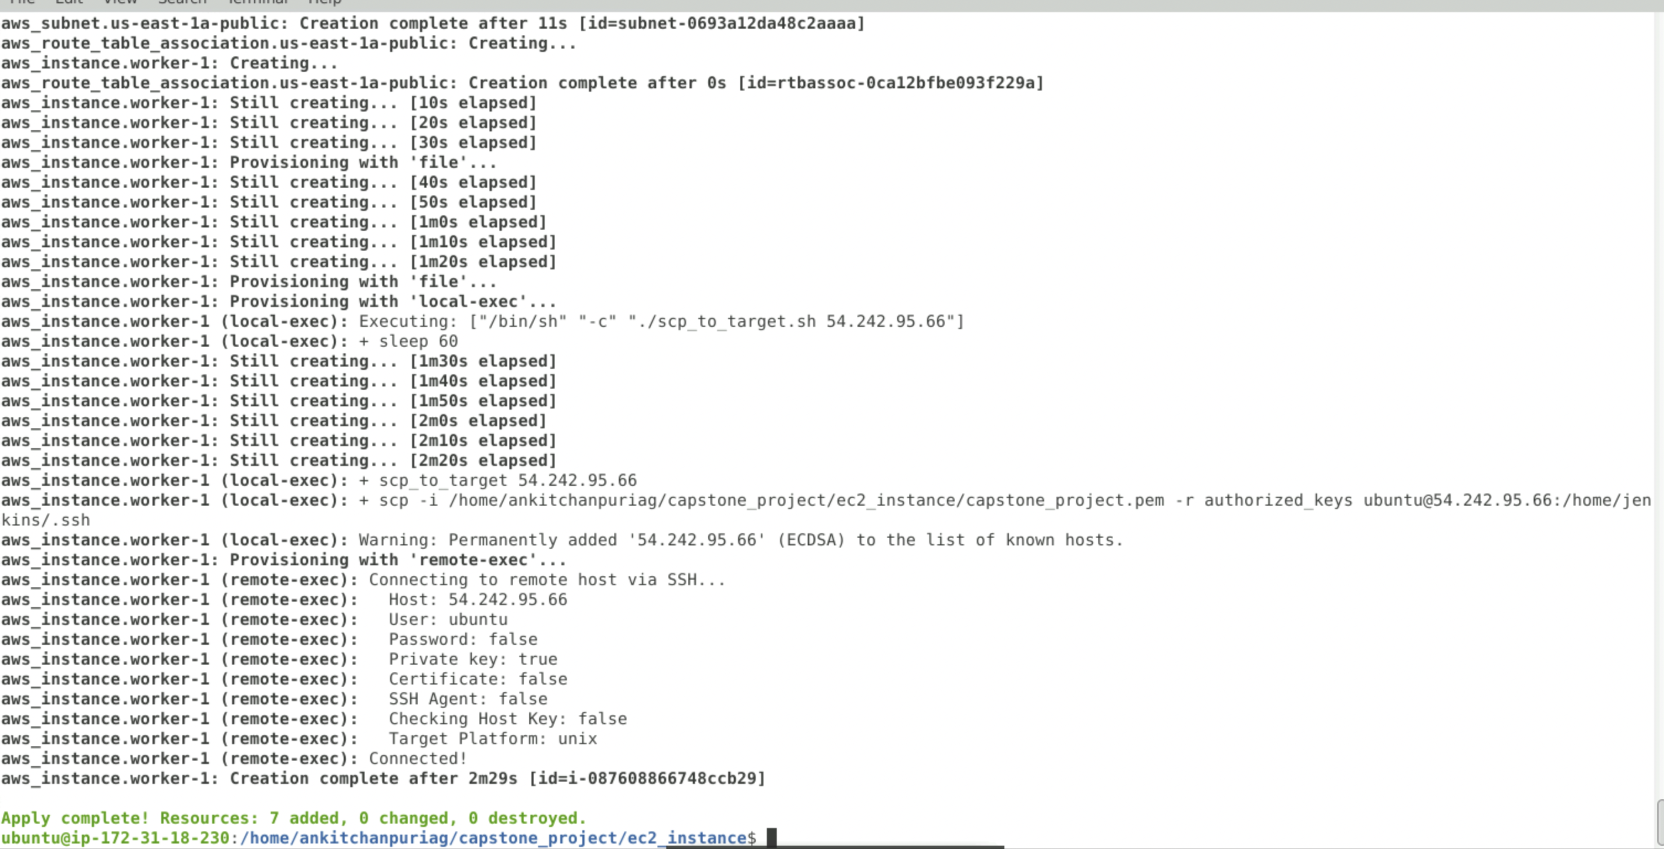

1. Now login to Jenkins slave and perform basic validations.

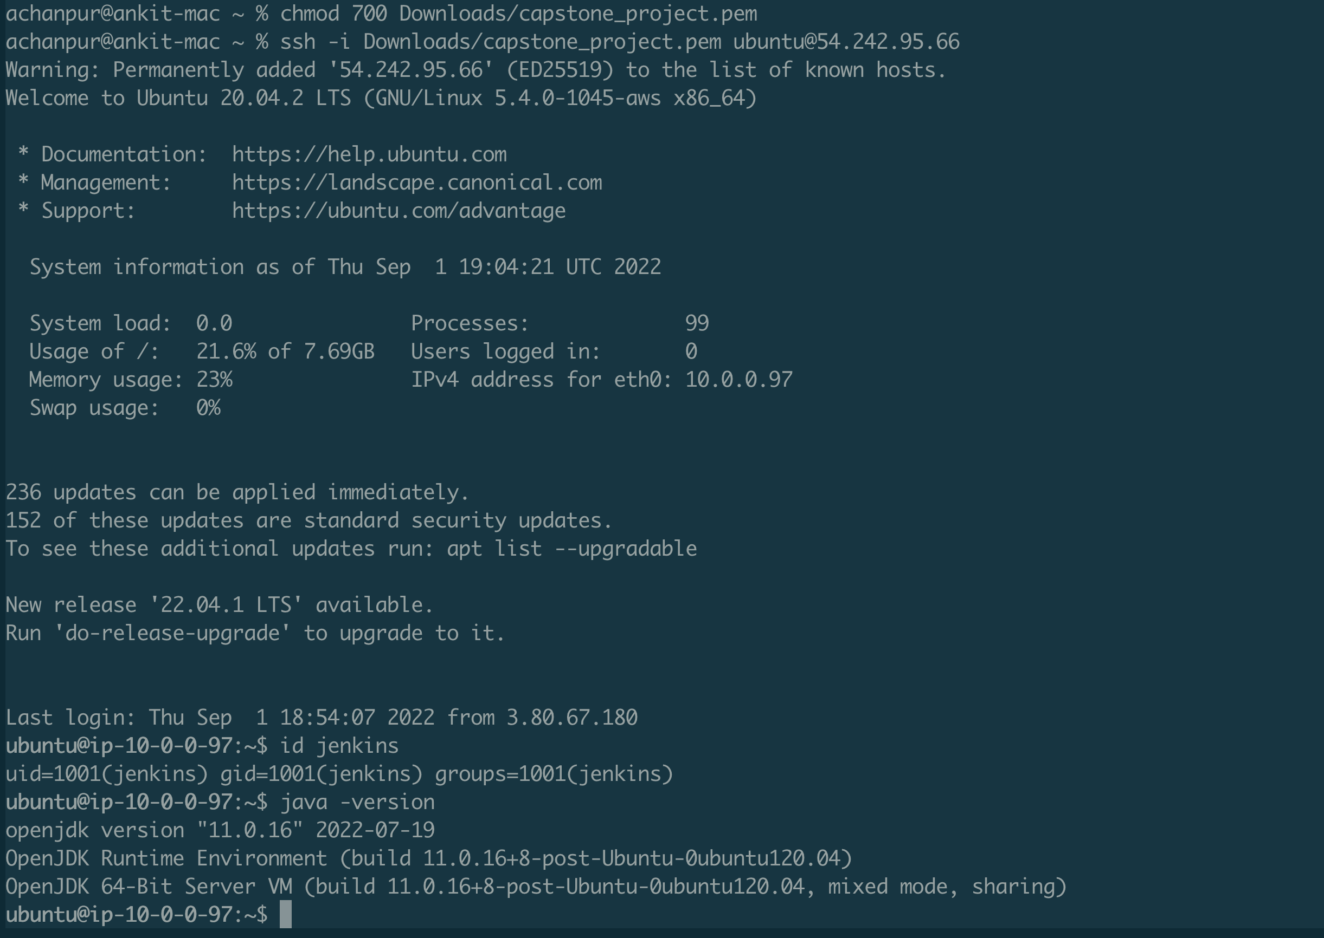

1. Now login to Jenkins master(http://localhost:8080/) and perform steps to add a slave/agent.
2. After login go to Manage Jenkins 🡪 Manage Nodes and clouds-🡪New Node

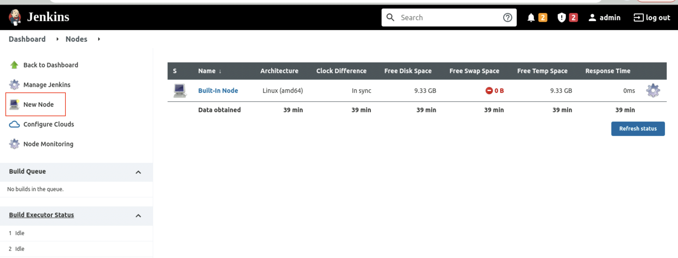

1. Enter node name as below

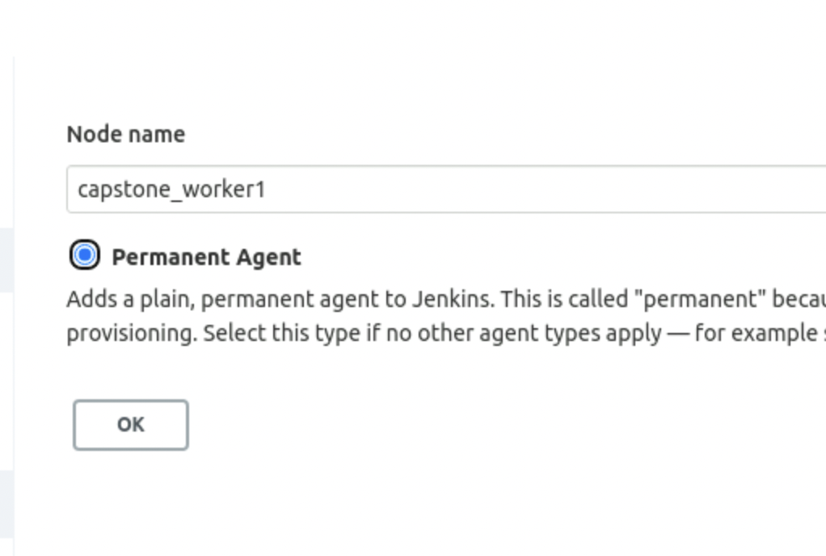

1. Enter details as below

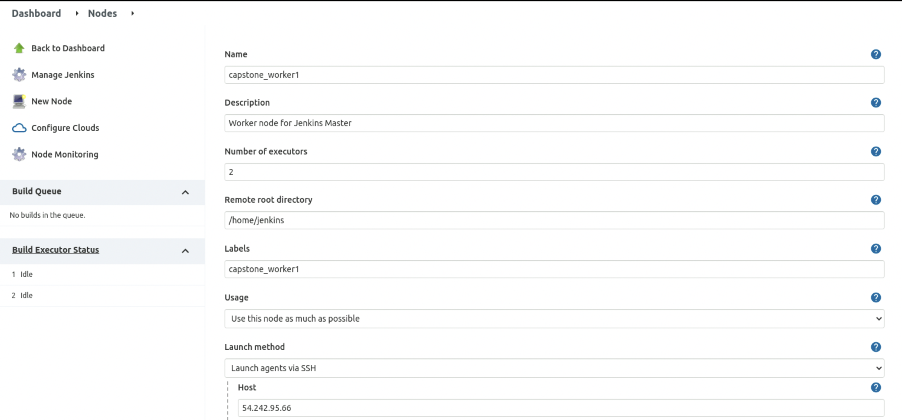

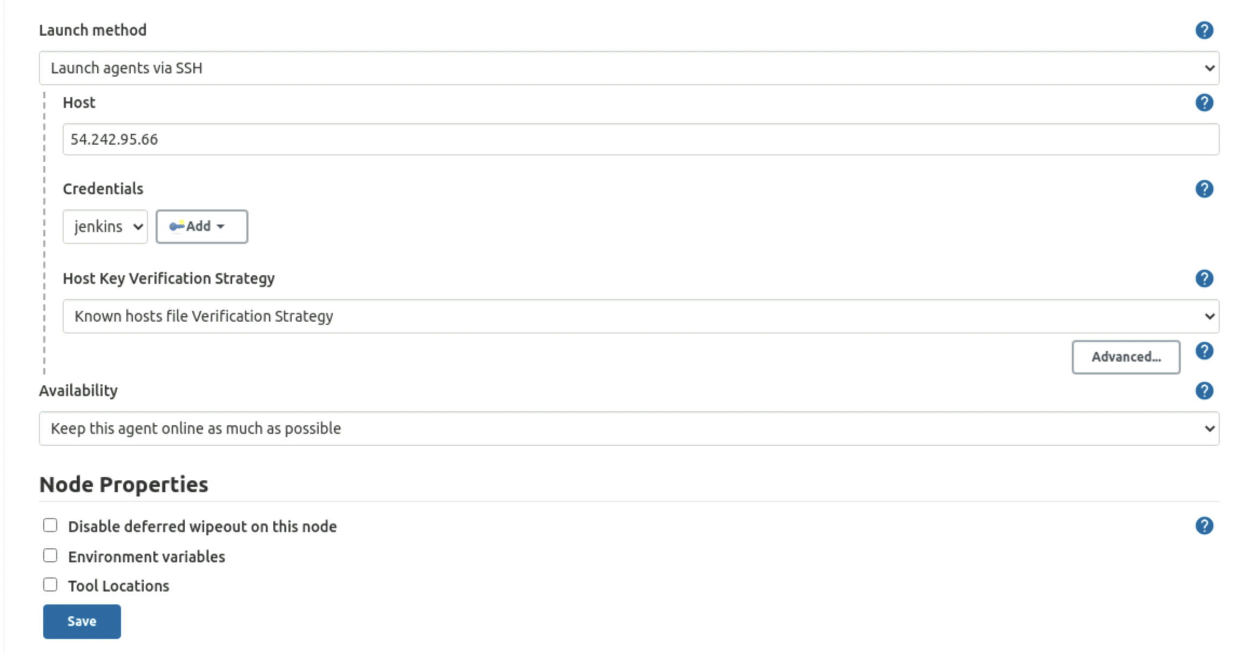

1. And we see agent has successfully launched and is online

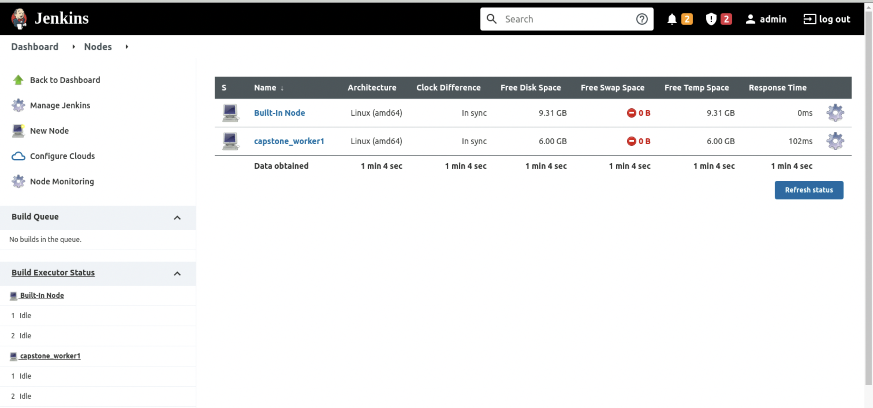

1. Now we create a pipeline called (capstone_project_pipeline) <http://localhost:8080/job/capstone_project_pipeline/> using groovy script, we define all the stages to launch a sample application.

Note: We create a dockerfile as below to launch application

FROM node:12-alpine

RUN apk add --no-cache python2 g++ make

WORKDIR /app

COPY . .

RUN yarn install --production

CMD ["node", "src/index.js"]

EXPOSE 3000

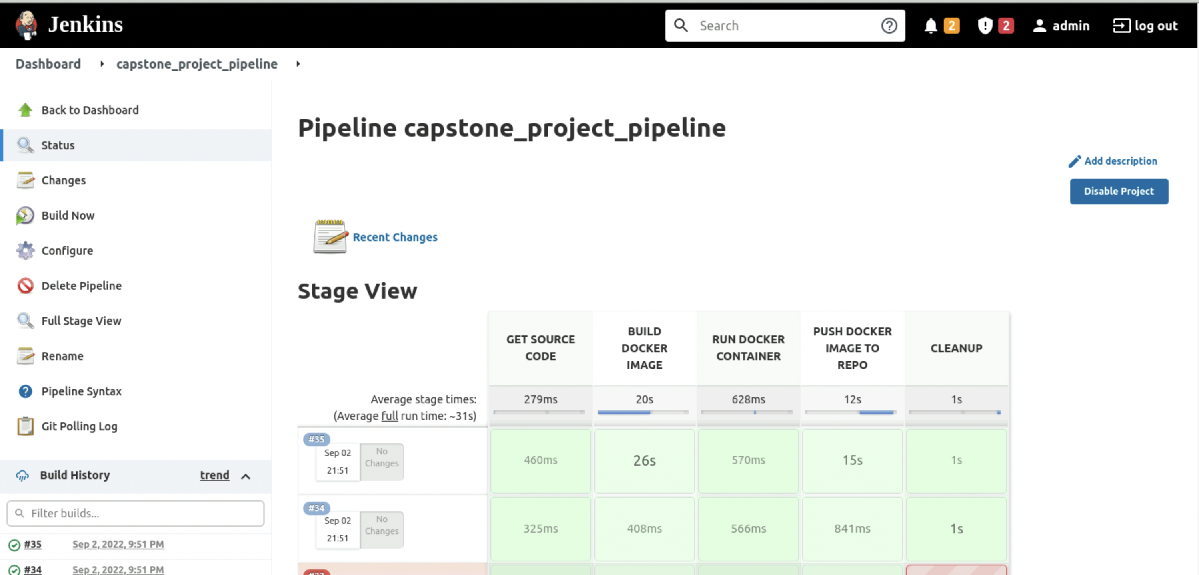

1. Now you can access the application as below

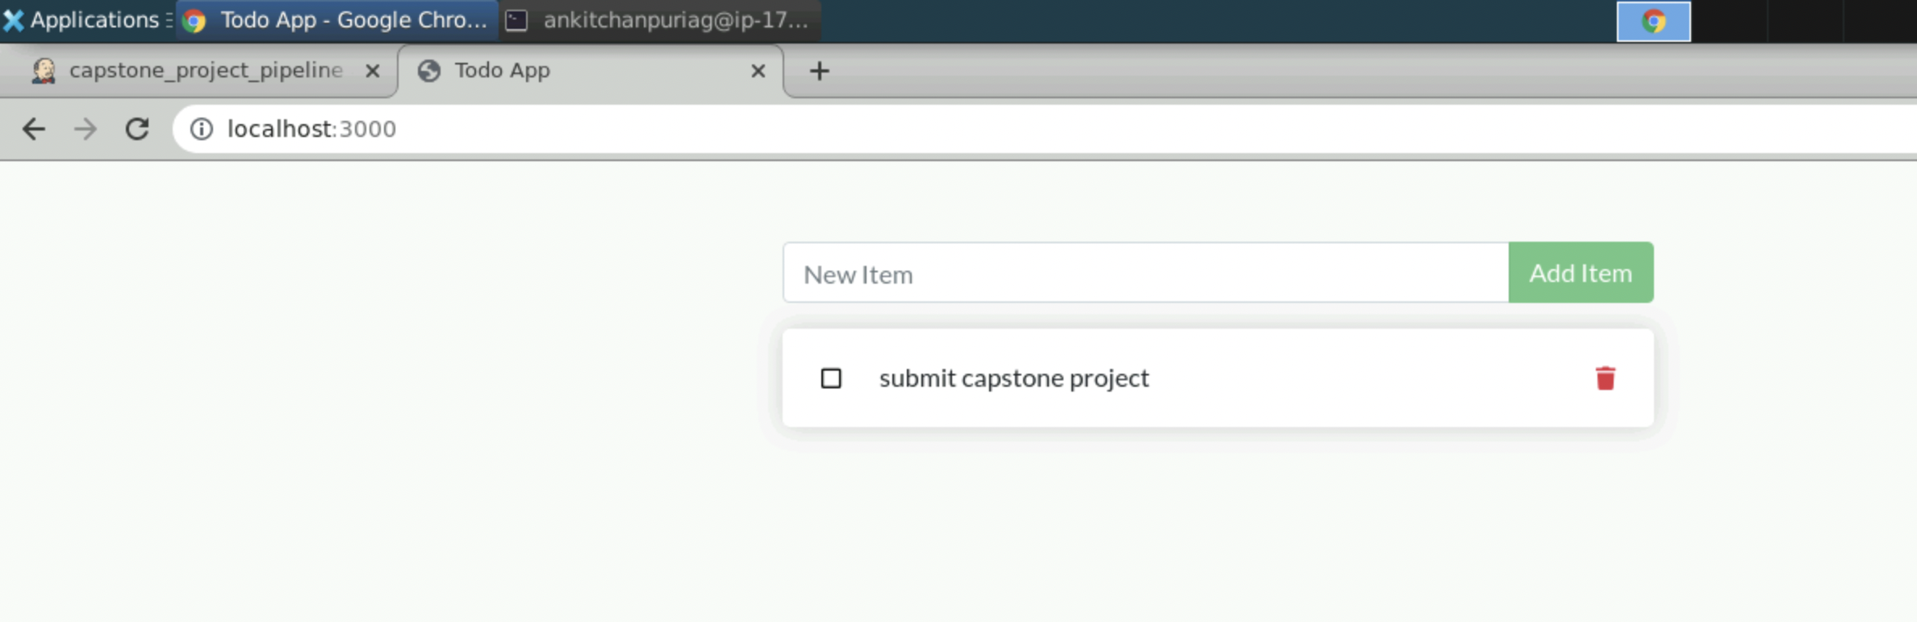

1. I have added an approval step before cleanup so that we can use application for the time we want and then proceed with cleanup as and when required.